Friday 12th June 2020
Year 1
English | Listen to the last part of the story here:  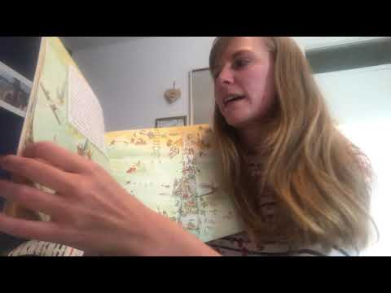  This week, our Theme has been Seaside Summer Holidays. In At the Beach, the family took their caravan and stayed at a campsite whilst they were at Crabby Spit.  Your mission for today is to design your very own Holiday Campsite! It can have whatever you’d like it to have! There might be: A swimming pool, a theme park, unlimited ice cream stalls or free sun cream!  You could draw your design, build your design using bricks/lego or you could create it in a shoe box! I’d love to see some signs for each part of your campsite, you could even design a leaflet to persuade people to visit and possibly include the prices of how much it would cost to stay there too!
Maths | Multiplication & Division Game  Hit the Button:  https://www.topmarks.co.uk/maths-games/hit-the-button  Click on the x2, x5 or x10 to see if you can find the answers to the questions given.  Thinking about multiplication and division/sharing that we have been learning about this week, today you are going to be making a card game to show off what you’ve learned!  Can you make a set of matching cards and questions where people need to match the answers to the Multiplication and Division/Sharing questions. You could draw pictures to show your answers, like in this doughnut question. Like these:  James has 15 doughnuts. He shares them with his 2 friends. How many doughnuts do they each get? (Remember there are three people)  They will each get 3 doughnuts each.  ooooo  ooooo  ooooo
Topic | For your English lesson, you were asked to design your own campsite, this afternoon you are going to design and create your very own seaside town! There could be bouncy castles, doughnut stalls, submarines to hire! It’s up to you!  Use the pictures of other seaside towns to help you design your seaside town!  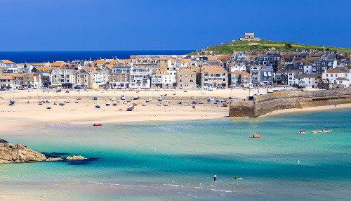  Think about whether you are going to charge people to visit and have a go at each activity or will people be allowed to use them for free?  What will you call your town? Have a go at creating your own sign to show people they have arrived!

