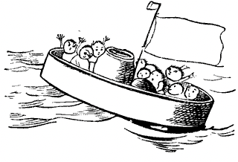
Can you draw a picture of the Jumblies and include all of the things in the list below?
sieve
sea
storm
green heads
blue hands
Jumblies
friends

