Wednesday 20th May 2020
Year 1
English | Poverty  What do you think the word poverty means?  Have a look at the PowerPoint attached to find out more.  Year 1: Using the information you have learned about Poverty, make an informative leaflet to teach people about what Poverty means.  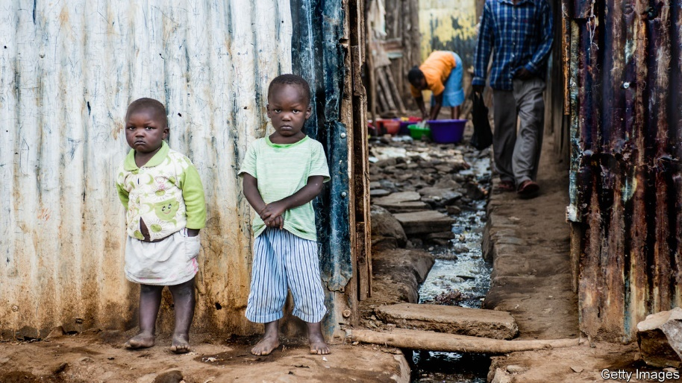  Then ask the children, how do you think we can help these people? If you saw these people in real life, what could we do to help?
Maths | Addition and Subtraction  Adding by making 10  (Adults, we did some work on this when we were back at school but the children found it a little tricky. It is a really helpful skill and I always reminded the children that the idea behind it was to make their lives easier because multiples of 10 were ‘easier numbers’)  Have a go at this question first to remind yourself of the method of making 10 first.  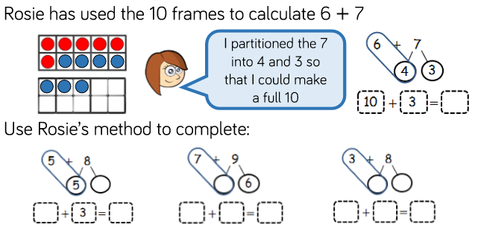  If you can, draw some 10 frames (start with 2) and practise filling one of the 10 frames up before moving on to the next one. (I have attached some if you are able to print them out, but they are easy to draw too).  For example: 5 + 8, ‘well I know that 5 + 5 =10, so if I use 5 of my 8, I have 3 left, if I then add the 3 onto the 10 I made earlier, I will have 13’.  Practise this method for these questions (a number line might be helpful for some of these):  Remember to make 10 first!  7+ 9 =  6 + 8 =  4 + 9 =  4 + 11 =  6 + 19 =  Once you’re confident with this method, have a go at the task sheet provided (this is useful as a visual aid even if your child isn’t confident yet)  Extra challenge:  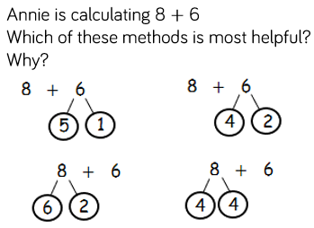
Topic | Day three of being stuck under the sea! It seems the submarine can no longer be fixed!  That means it is up to us to create a vehicle which will be able to hold all of the class (21 people but don’t worry Ms Everett can drive it) all the way back to shore!  These are some things we have found whilst being stuck at the bottom of the ocean, could you use these in your design?  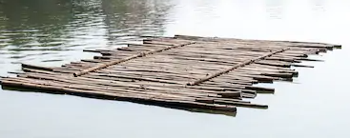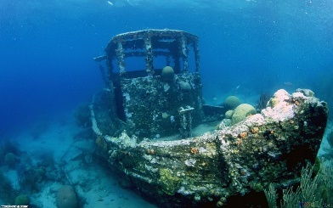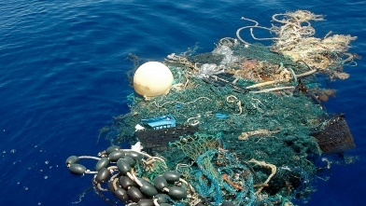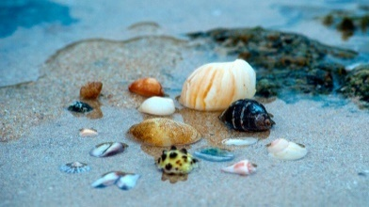  Have a go at the ‘How Fish Breathe’ science experiment

