Children’s Mental Health Week: Week Beginning: 1st February: Theme – Express Yourself

Talk! | Get Thinking! | Create! | Move and Listen! | Write!
Share some happiness!  Find a time to turn off all devices and talk. Share the best bits of your day or your favourite memories. | What things make you feel happy?  Sad?  Angry?  Excited?  How do you show these different emotions?  Track your emotions by creating:  Create a book of faces of how you may be feeling – happy, sad, excited. | Dress to Express Day!  Create something to wear on ‘Dress to Express’ day this Friday. You could decorate something you already own or make a hat or accessory to express yourself.  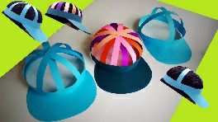  Use your favourite colours, patterns and shapes! | Put on your favourite music and dance around the room! How does it make you feel? What sort of movements do you enjoy making? | Start writing a diary to express yourself. A diary is a safe place to keep your thoughts. It’s okay to write both positive and negative things in a diary – it’s totally up to you!
What’s on your mind?  Talk about the things that are worrying you or you feel unsure about. It can really help to talk things through! | How do you let off steam?  Think about what you do when you are feeling sad or angry.  What helps you to feel better? What other ideas could you try?  Remember this advice for when a friend might need it! | Take your pen or pencil for a walk around the page without taking it off. What shapes can you see? What could your lines represent? | Sing along to a song you like. What do the lyrics mean to you? How do you feel when you sing them? | How many emotions?  Write down all the emotions you have felt today! Some days, you may feel lots of emotions but other days, maybe just one or two.  Choose a different colour to express each one and decorate them.
Catch up with a friend you haven’t spoken to for a while.  This could be someone from school who you cannot see at the moment. Check in and see how they are. Let them know how you are feeling too. | A-Z Emotions  How many different emotions can you think of?  Can you name an emotion for each letter of the alphabet? | Splash some paint in the colours that show your emotions! (Make sure you check with an adult and use an apron/table covering.)  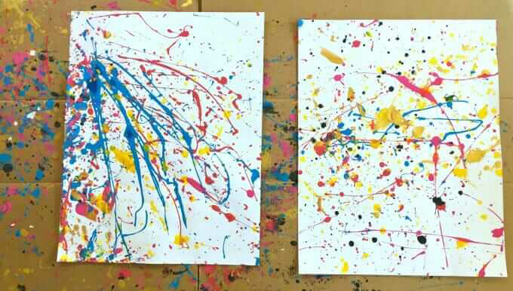 | Happiness Playlist  Create a playlist of songs that make you feel good!  Share it with friends and family so they can use it too.  Which songs have you included and why? How do they make you feel? | Write a letter to yourself about how you are feeling and why!  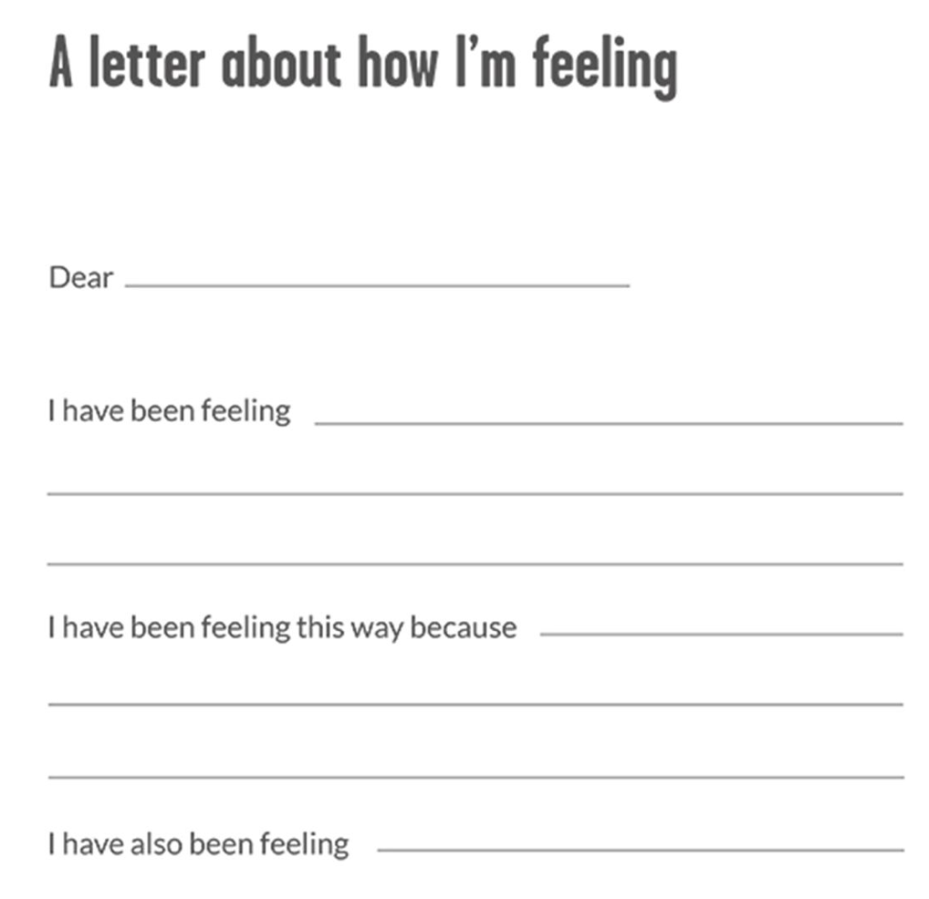
Check-In  Let people around you know how you are coping with lockdown.  What is difficult about being in lockdown?  Are there any silver linings that you are enjoying? Send a letter to someone you miss? | What are your proudest achievements and how did they make you feel?  Try to think of a small goal to work towards each day so you can feel that same sense of achievement. | Happy Box!  Make yourself a box of all the things that make you feel happy and safe. You could use an old shoe box and decorate it.  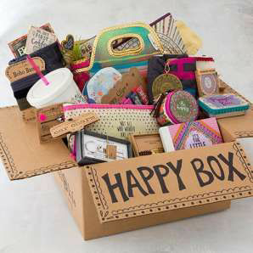  You can look at this when you are feeling scared or worried | Be a Dance Teacher!  Plan a dance routine to a song you love and try to teach it to someone else. This could be someone in your house or even someone you can contact on Zoom. | The Story of You!  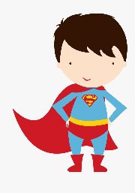  Write a story with you as the main character. You can be anything you want to be – a superhero, a spy, or simply your amazing self!  Where will you go? What will you see?
Talking Mental Health  What does mental health mean to you?  Talk to someone at home about what good mental health looks like and what you can do if you have any mental health worries. | How will you be kind today?  Acts of kindness always are always a great idea for our own and others’ mental health.  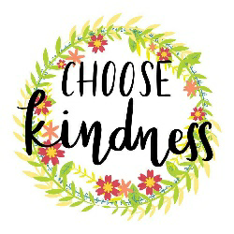  Try to think of at least 5 kind acts to do! | Nature Art  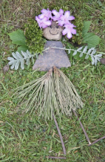  Whilst out on a walk, collect some items along the way that interest you. Take them home to create a piece of natural artwork. | Find something energetic to do for at least 30 minutes. Try to make sure that you increase your heart rate. You could try running, practising some sporting skills, trampolining or testing your fitness. | Write a poem to express your feelings. It could be about an experience and how you felt, about a particular emotion or about all the different feelings you have at different times.
Talk to someone about what it means to be a good listener.  You could create a poster with some top tips!  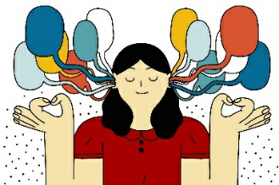 | What do you see?  Look at yourself in a mirror. What do you see?  Study your reflection and think about how you express yourself to others every day.  What changes do you notice on your face when you smile or frown? | The Island of You!  Design an island all about you, full of your favourite things and favourite people. Buid a model of your island using whatever you can find – recycling, Lego etc. | Create your own song, rap or tune to show how you are feeling!  You can use your voice, an instrument, or even a household object to create interesting sounds to use in your piece of music. | Who are you?  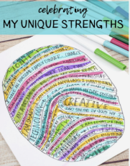  Draw your thumbprint in as much detail as you can. Write about yourself between the lines to express who you are… I am creative, I am a kind…  Use your favourite colours!
Additional ideas:

- Lego challenge
Can you create your dream house out of Lego?
Who in your house can build the tallest Lego tower?

- Track your emotions
Draw an emoji each day to show how you are feeling.
Make a playdough emoji each day and collect them in a jar of feelings!

- Colouring in

- Go for walks/bike rides

- Try a new hobby!

- Design and make a board game

- Scavenger hunt
Go on a scavenger hunt around your home, finding different things that represent you and your family.

- Fitness challenge
Challenge someone in your house or someone else you can contact to a fitness battle. See who can do the most sit ups or push ups in one minute, or come up with your own ideas.

- Calm corner
Create a calm, comfortable corner someone in your home. Spend some time there when you need to relax.

- MasterChef!
With an adult, Can you create a masterpiece in the kitchen for the family to share and enjoy?

