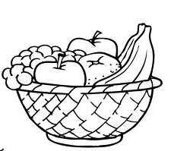
Favourite Fruit

Shoppers in the supermarket were asked in a survey which was their favourite fruit. Here is a list of their responses.

Banana Apple Banana Banana Grape Orange
Apple Apple Strawberry Orange Apple Banana
Orange Orange Strawberry Banana Grape Apple
Apple Apple Orange Strawberry Strawberry Apple

Complete this Tally Chart and use this information about favourite fruits to fill it in. Then answer the questions below.

FRUIT | TALLY | TOTAL
Apple
Banana
Grape
Orange
Strawberry

- Which fruit was the most popular? .

- Which fruit was the least popular? .

- Which two fruits were preferred by the same number of people?

and .

- How many more people preferred Apples to Grapes? .

- How many fewer people preferred Strawberries to Bananas? .

- How many people were surveyed all together? .

- Order the fruits from most popular to least popular?

