Thursday 4th June 2020
Reception
Phonics  English | -Writing Captions  Ask the children what they can see in this picture:  Write the following with your child: a bridge in the wood  Explain that this is a caption (a title for a picture)  Ask the children where the trees are in the picture (around the bridge) – write this caption with the children: trees around the bridge  Independent activity: match the caption with the pictures in the attached activity.  Watch today’s entry of the Naughty Bus  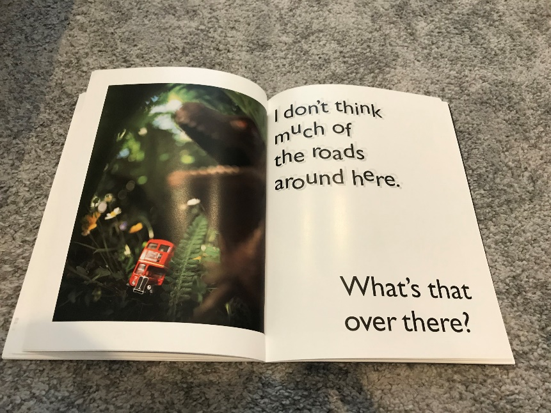  Why do you think the words are shown like this? (To show that the bus is bumping up and down on the grass)  Reception: Imagine you are sat on a bus as it bumps over the grass! What do you think the bus has spotted? How do you think the bus feels in this picture?  Reception: Explore reflections in your house (or local pond), fill a bowl/bath/sink full of water and see if you can make some of your own reflections with items around the house. What do you notice? What happens if you splash the water when you are making a reflection?  Ask the children to have a go at writing a caption for this picture: 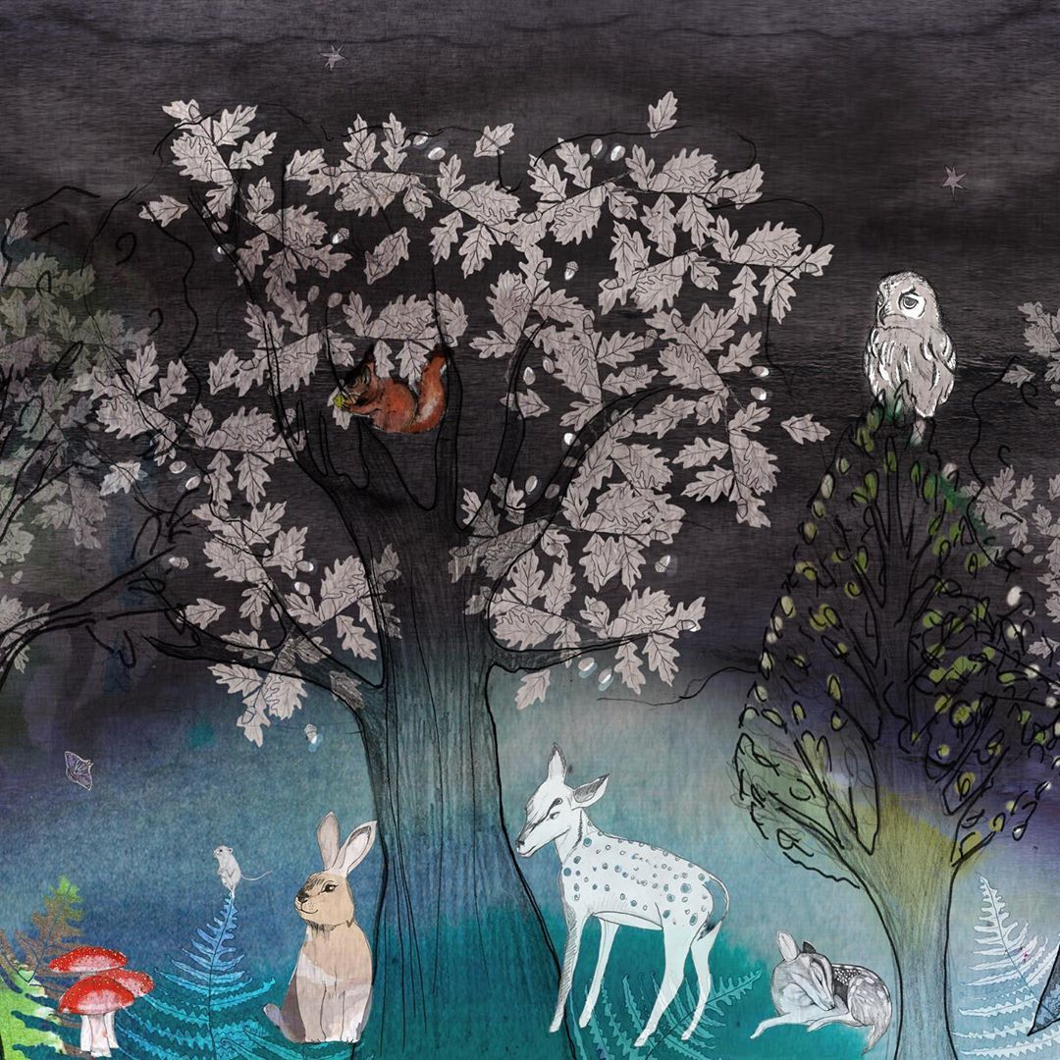  (Select an animal and write about where it is located e.g: owl on top of the tree)
Maths | Months of the Year  Listen to this catchy song singing the months of the year to help you remember!  https://www.youtube.com/watch?v=Fe9bnYRzFvk&vl=en  Write out each of the months of the year and discuss as a family some occasions which happen in each month – birthdays, anniversaries, special celebrations in your family!  Cut and stick each of the months in the right order!
Topic | Airplane  Another method of transport we can use to take us to different places is by airplane!  Listen to this story about a girl who flies over different cities in her airplane: https://www.youtube.com/watch?v=TqTf0zwyVR4  The Wright Brothers were the first people to successfully fly an airplane! Learn about their journey here: https://youtu.be/YDlk4Ky_ahs  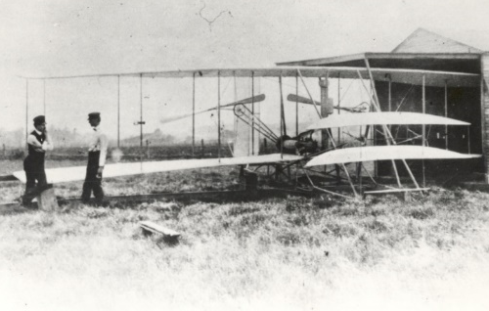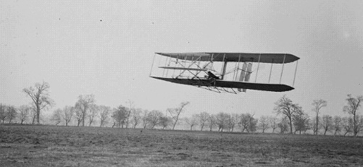  If you have enough space outside, measure a line of 12 metres, this was how big the wings were of the airplane!  If you were able to interview the Wright’ brothers, what would you ask them?  Let’s explore: Today’s challenge is to create 3 different paper airplanes, they all have to be different, here are some ideas: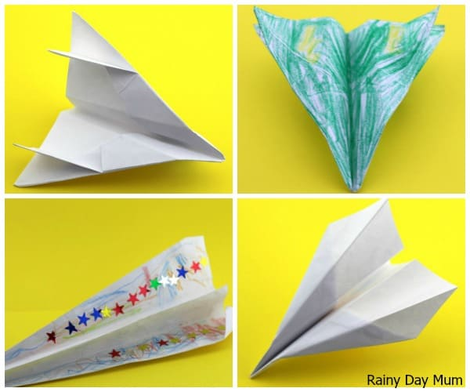  Test each of your airplanes and see which one travels the furthest! I’d love to see some videos of your paper airplanes!

