24/03/2020 Soils
Date your book. Write the answers in your book. Can you remember what soils are made up of?
Soil is made up of:
- A………………………………
- W……………………………..
- O…………………M……………….
- M……………………………….
Draw the soil profile in your book using a pencil and colour neatly.
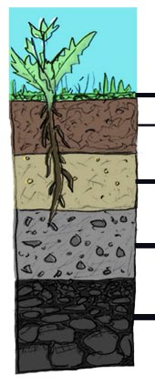
Label it and write the sentence next to the correct part of the diagram
Bedrock
Topsoil
Organic layer
Subsoil
Parent Rock

Parent material

Parent Rock: Slowly over time the big rocks break down to become the parent rock.
Organic Layer: This is the dead leaves and animals which is slowly decaying because of soil bacteria. It helps to form organic nutrients which plants need to grow.

Bedrock: The big rocks at the bottom. They’re like the grandparents of the soil.

Subsoil: Small particles of rock which have been broken off from the parent rock. Parts become smaller and smaller to become the soil.

Topsoil: This is the only part of soil that we can grow plants. It is rich in nutrients which help the plants grow. This is where we will find Lots of worms!

