Wednesday 3rd June 2020
Year 1
Phonics  English | -Write the following sentences with ’oa’ phonemes (think about the best fit activity from the previous phonics lesson):  The old toast is as hard as stone.  Will you moan if your phone is thrown out of the window?  Will a bad throat or a bad toe make you croak like a toad?  -Reading Robot practise: https://new.phonicsplay.co.uk/resources/phase/5/reading-robot (Practise Phase 5)  Watch today’s instalment of Naughty Bus read by Miss Gannon!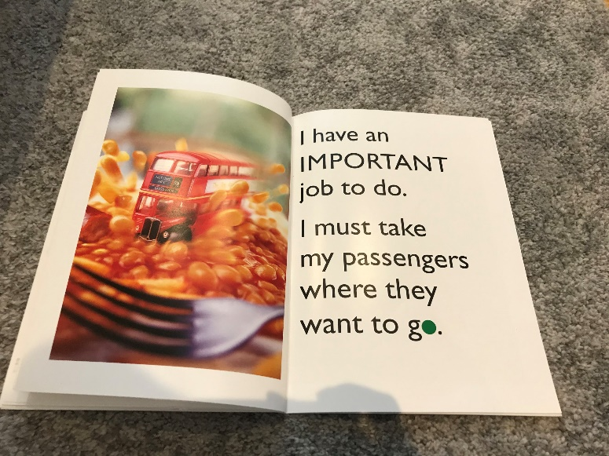  Year 1: Who is telling this story? (I refers to the bus) Why do you think the word ‘go’ has a green circle for the o? (it looks like the green light of a traffic light, green means go!)  Can you create sets of rhyming words for the picture: like baked bean and mean, bus and fuss, fork and talk.  Can you write a poem using these words for the picture.
Maths | 3D Shapes  You have 1 minute to name as many 3D shapes as you can… GO! Bonus points if you can draw them too!  Remind yourself of what 3D shapes are in this video: https://open.online.clickview.co.uk/libraries/categories/26204561/videos/3711988/describing-3d-shapes  For today’s lesson, you are going to practise drawing the 3D shapes on dotted paper – 3D shapes are really tricky to draw but the more you practise, the better you’ll get!  For an additional challenge you could design a card game of ‘Who am I?’ where you’ll need to write clues about each 3D shape so that players could match the written clues with the shape name!
Topic | Trains & Trams  Fun fact: the word ‘train’ refers to the whole of the locomotive & the coaches/carriages.  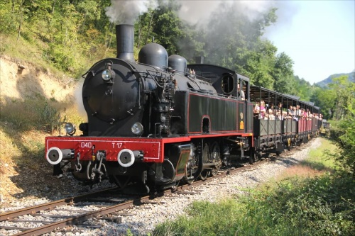  A locomotive refers to the engine that pulls the train.  Take a look at the powerpoint showing how Trains have changed through time. What do you notice?  There are different types of locomotives, some run on coal:  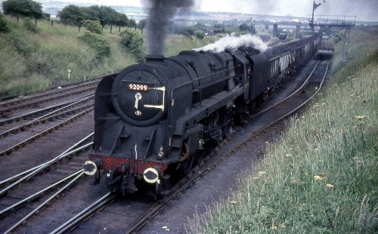  some diesel:  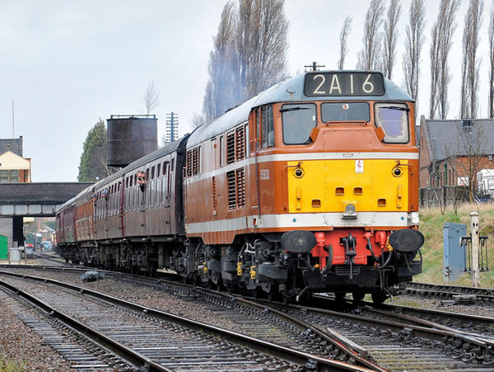  and some on electricity:  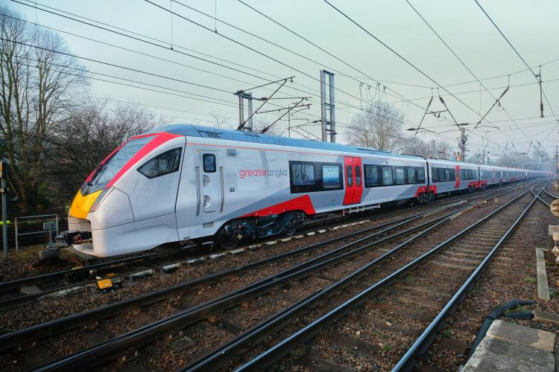  Trams are another type of transport that use electricity too: 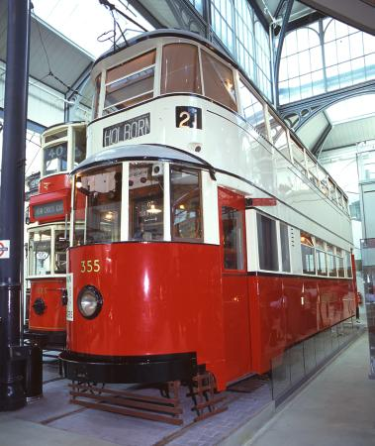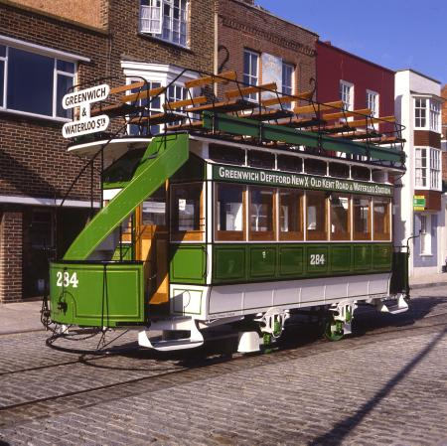  What similarities and differences can you spot between the trams and trains?

