Use the clues to work out which fraction is being described and which shape represents each fraction. Record the correct shape underneath each clue.

- My denominator is 9 and my numerator is one less than my denominator.
___________________

- I am equivalent to
___________________

- I am more than the shape equivalent to
____________________

Can you record the fraction that each shape is worth? Can you record an equivalent fraction?
=
=
=
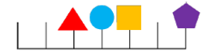
- My denominator is 6 and my numerator is half of my denominator.
___________________

- I come before the shape equivalent to and I am equivalent to
___________________

- I am equivalent to 1.
___________________

- I am the same as
___________________

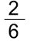
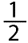
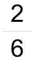
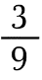
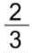
Can you write what fraction each shape is worth? Can you record an equivalent fraction?









