

My Foodimal Character

Foodimal Name:

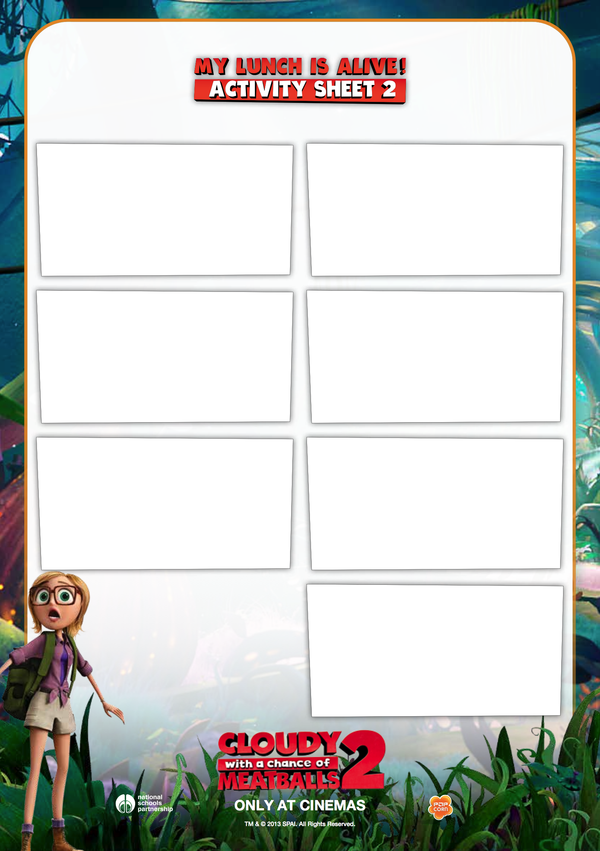

How does it move?

How does it behave?

Where does it live?

How does it speak?

What does it eat?

What is it afraid of?

Who are its friends?