[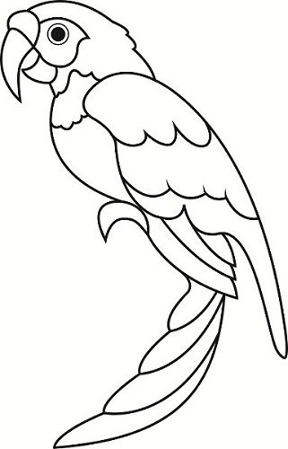](https://www.google.co.uk/url?sa=i&url=https://paintingvalley.com/parrot-drawing-outline&psig=AOvVaw1FHUuDVhVO9M18dfHDvcFH&ust=1590669365281000&source=images&cd=vfe&ved=0CAIQjRxqFwoTCLj08N-H1OkCFQAAAAAdAAAAABAD)