Look carefully a the 4 different paintings of the beach huts at Wells Next the Sea.

Can you create your own BEACH HUT art work? You can draw, paint, use chalks or even make a collage.

Make sure each hut is UNIQUE – just like the real ones.

[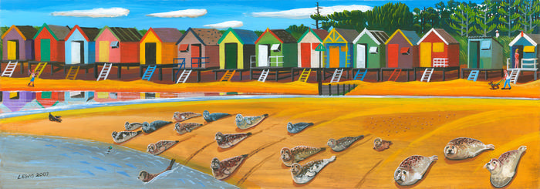](https://www.google.co.uk/url?sa=i&url=https%3A%2F%2Fwww.art-e-mail.com%2Fseal-art-prints-by-brian-lewisseals-wells-next-to-sea-974-p.asp&psig=AOvVaw2eA2ACsPT49VmWsSk-nVRi&ust=1587577211330000&source=images&cd=vfe&ved=0CAIQjRxqFwoTCPC9muqI-ugCFQAAAAAdAAAAABAD)

[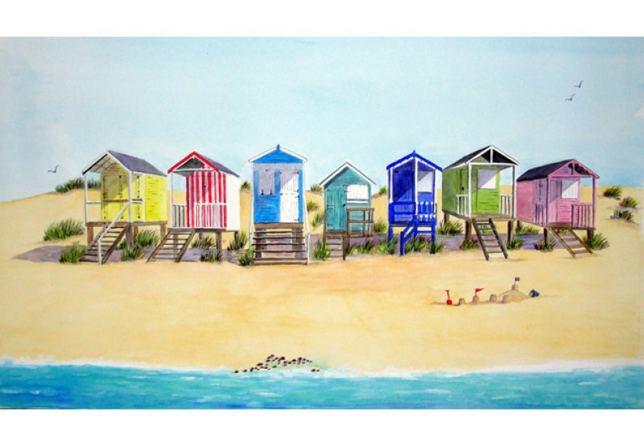](https://www.google.co.uk/url?sa=i&url=http%3A%2F%2Flynetteameliepaintings.co.uk%2Fgalleries%2Fview%2F54%2Fwells-next-the-sea-beach-huts&psig=AOvVaw2eA2ACsPT49VmWsSk-nVRi&ust=1587577211330000&source=images&cd=vfe&ved=0CAIQjRxqFwoTCPC9muqI-ugCFQAAAAAdAAAAABAK)

[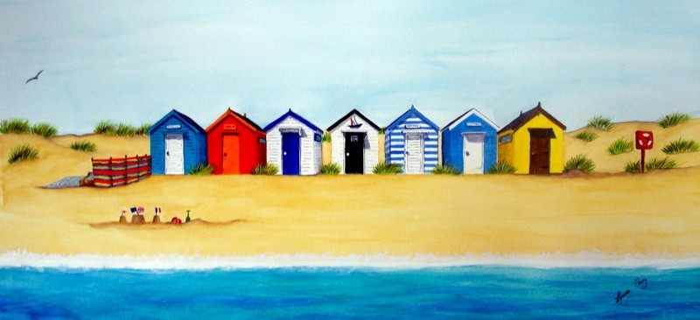](https://www.google.co.uk/url?sa=i&url=http%3A%2F%2Flynetteameliepaintings.co.uk%2Fgalleries%2Fview%2F80%2Fbeach-hut-picnic&psig=AOvVaw2eA2ACsPT49VmWsSk-nVRi&ust=1587577211330000&source=images&cd=vfe&ved=0CAIQjRxqFwoTCPC9muqI-ugCFQAAAAAdAAAAABAQ)

[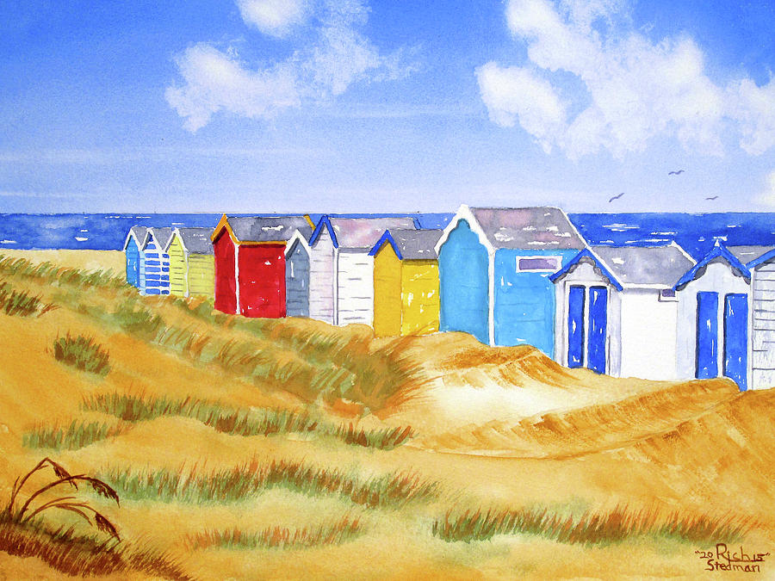](https://www.google.co.uk/url?sa=i&url=https%3A%2F%2Ffineartamerica.com%2Ffeatured%2Fbeach-huts-rich-stedman.html&psig=AOvVaw2eA2ACsPT49VmWsSk-nVRi&ust=1587577211330000&source=images&cd=vfe&ved=0CAIQjRxqFwoTCPC9muqI-ugCFQAAAAAdAAAAABAX)