[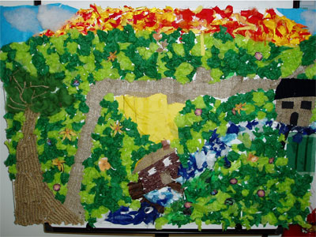](https://www.google.co.uk/url?sa=i&url=http%3A%2F%2Fwww.creative-corner.co.uk%2Fschools%2Fmec%2Fwhat_we_do%2Fgifted_and_talented%2Fpupil_galleries%2FCollage%2520Workshops.shtml&psig=AOvVaw04g6ZPRYe0-RQmub9uYpks&ust=1588165335914000&source=images&cd=vfe&ved=0CAIQjRxqFwoTCPCUksSXi-kCFQAAAAAdAAAAABAD)Paper collage

[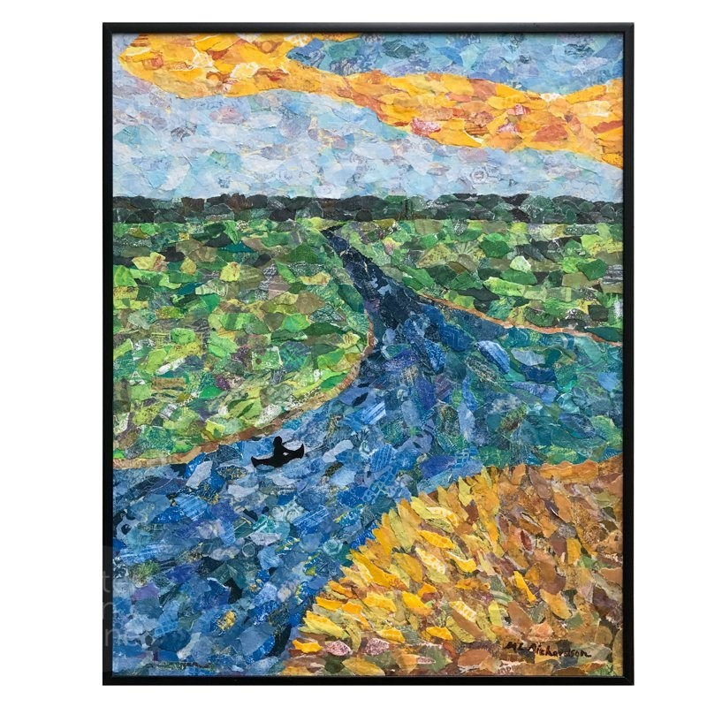](https://www.google.co.uk/url?sa=i&url=https%3A%2F%2Fwww.h2oonstone.com%2Fstore%2FThe-Rivers-Will-Act-Torn-Paper-Collage-p132617237&psig=AOvVaw1XfqwLpum88Zgw35IdXAiJ&ust=1588164725471000&source=images&cd=vfe&ved=0CAIQjRxqFwoTCIjCupuVi-kCFQAAAAAdAAAAABAE)

[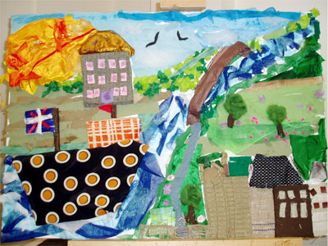](https://www.google.co.uk/url?sa=i&url=http%3A%2F%2Fwww.creative-corner.co.uk%2Fschools%2Fmec%2Fwhat_we_do%2Fgifted_and_talented%2Fpupil_galleries%2FCollage%2520Workshops.shtml&psig=AOvVaw04g6ZPRYe0-RQmub9uYpks&ust=1588165335914000&source=images&cd=vfe&ved=0CAIQjRxqFwoTCPCUksSXi-kCFQAAAAAdAAAAABAO)

[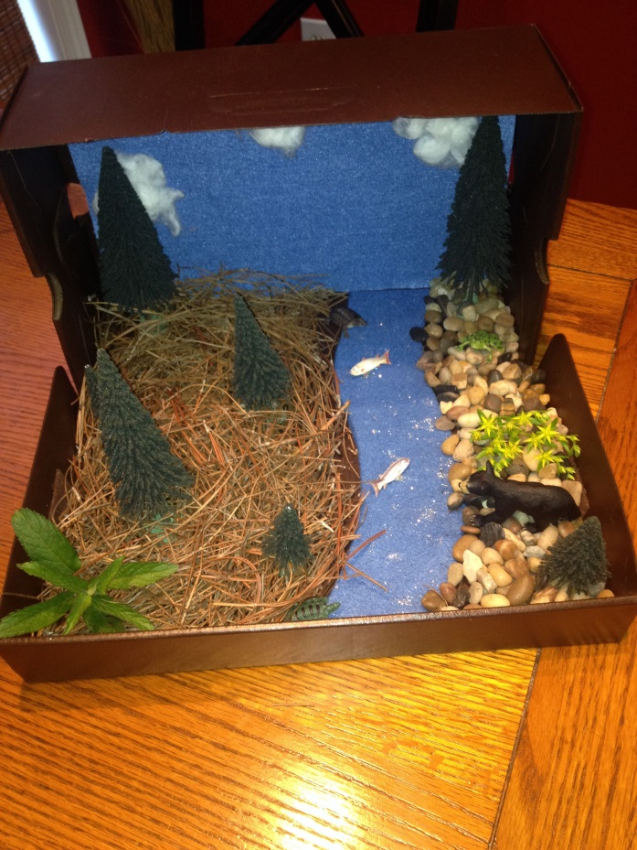](https://www.google.co.uk/url?sa=i&url=https%3A%2F%2Fwww.pinterest.com%2Fpin%2F108438303502426530%2F&psig=AOvVaw3nVhuCLe32pknQflpymOxE&ust=1588165610557000&source=images&cd=vfe&ved=0CAIQjRxqFwoTCMCemr-Yi-kCFQAAAAAdAAAAABAD)

OR

You could even make a river in a box!