7th May 2020
Reception
English
Design a picnic!
When Gregory and his family were on the beach, they sat down and had a picnic.

Can you design your own menu of things you’d like to eat at a picnic? Here’s an idea of how you could lay it out.

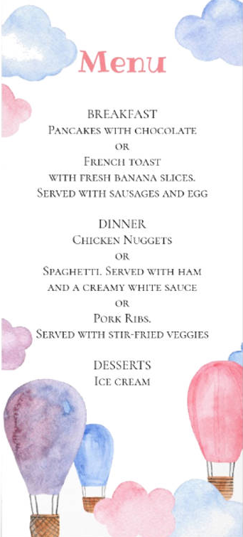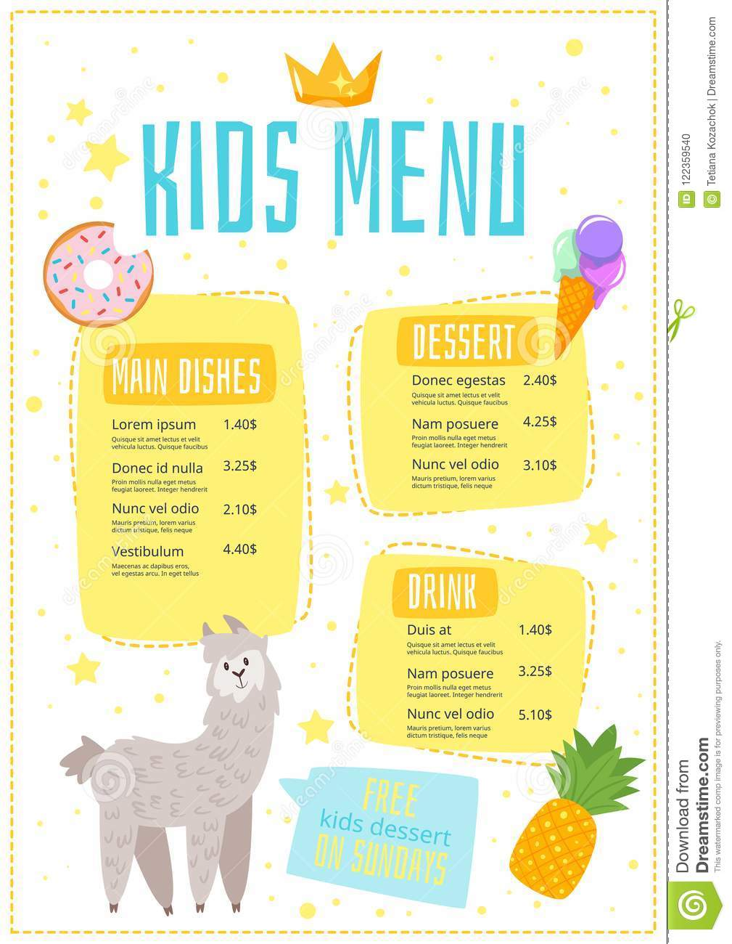

Maths:
Have a go at one or two of the challenges in the sheet attached to do with measuring time.

A Tour of Tobago
(Parents: I have watched this video all the way through and wanted to mention that the journalist discusses the name of on the of the bays briefly. The name of the bay is Bloody Bay and the history behind it involved a ‘battle’ so you may want to skip this section of the video (at about 5:13) but other than this, it is a fantastic visual for the children about what the island is like).

Now that you’ve mastered human and physical features and have had a look for some in your local area, this time we are going to look for them in Tobago! Watch the video below to find out exactly what the island looks like, whilst looking for the physical and human features!
https://cdn.theguardian.tv/mainwebsite/2013/10/30/130908BAtobagoWITHLOGO-16x9.mp4

Here are some pictures of some fantastic wildlife I noticed on another video I watched about Tobago, I thought I’d share them with you:
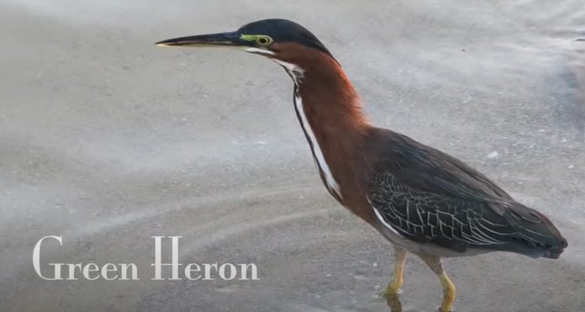

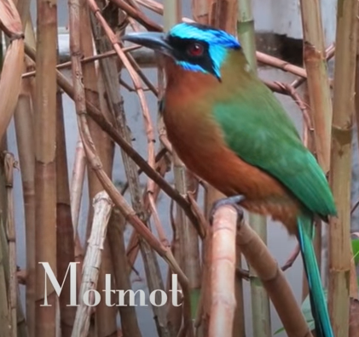
Bamboo plant:

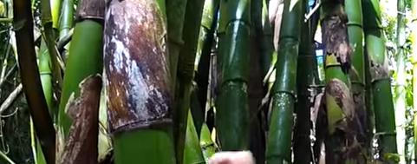

Look at the trunk of this tree! 