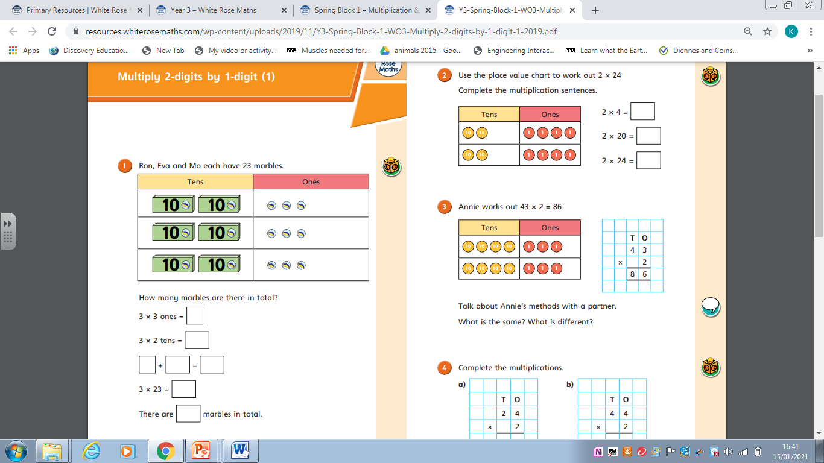

Use the grid method to work out:

25 x 5 6 x 24 35 x 3 4 x 36 31 x 3 42 x 4

Remember to use your ruler to draw you grid and set it out correctly. Partition the 2 digit number.