Nar Valley Federation

5-week Animal Project

For the next 5 weeks we are going to be working on an animal project. Mrs Neary thought that this would be a lovely way for the whole of the Federation to complete the last few weeks of this academic year.
Each week there will be a different element that looks at different habitats or types of animals. These will build up week on week to create your overall project, which we would like you to bring into school when we return, so that we can share and celebrate the learning that you have been doing.
- Week 1 – Nocturnal Animals
- Week 2 – Peru – South American Animals and Habitats
- Week 3 – Sea Creatures
- Week 4 – African Animals – The Savannah
- Week 5 – Endangered Animals

We will be covering all different areas of the curriculum during the weeks and providing links, videos and other useful resources and ideas.

Nar Valley Federation – Animal Project
Endangered Animals

Vocabulary:
prey predator habitat behaviour nocturnal night dusk twilight forage hunt/hunter creature species senses physical traits adaptation manoeuvrability
Book Ideas:

EYFS / KS1

Elmer
We’re going on a bear hunt
Bears don’t eat egg sandwiches
Very important animals
You can’t take an elephant on the bus!

KS2

The Akimbo Adventures
The Hunter
The Butterfly Lion
The White Giraffe

EYFS / Y1

YR/ Y1 - Watch and learn about animals such as tigers and why there are not very many of them left in the world.

https://www.youtube.com/watch?v=7k8CcAU2Lt0

Task 1

Using 6 sheets of A4 paper or card make 6 triangles like this
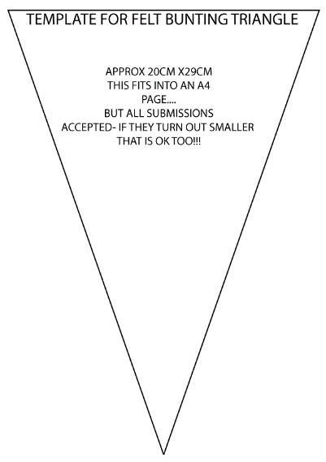

Once you have cut your triangles out fold over a 1cm strip.
You are going to draw an endangered animal on each one.
- An elephant
- A tiger
- A rhinoceros
- A panda
- A gorilla
- A turtle

Reception Children: Turn over your triangle and write the name of your animal on the back.

Year 1 Children : Now you are going to turn your triangle over, and you can write one fact about each of these animals.

Ask your parents to help you find a fact about each animal – you can use websites like this one.

https://www.dkfindout.com/uk/more-find-out/special-events/endangered-animals/

https://animalfactguide.com/animal-facts/

After that, place your triangle with the flap over some coloured wool or string and make your bunting.

Task 2

Watch the video link and see if you can learn the song.

‘I had a little Turtle’

https://www.youtube.com/watch?v=rmZySo0OHIQ

Task 3

Story - How the Tiger got his stripes

https://www.youtube.com/watch?v=rf7ascNGbcM

Year 2

Tiny Dragon

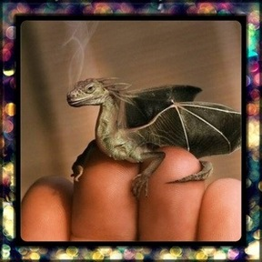
Questions for discussion:
- Where is it from?
- Why is it so small?
- Are there more like him?
- Where does he live?
- How will you look after it?
- Will you keep it a secret or tell someone?
- What is it called?
- Is it magic? What magic can it do?
You are going to create a book all about the travels of this tiny creature.
You need to work out the answers to the questions above before you start. Then develop your story line. Will it be an adventure, or a mystery story.
Each page in your book will have a picture created by you on half of it and you write the story in the other half.
Create a front cover and give it a title – look at some of your books at home to give you some ideas.
Take your time and do this work over 2-3 days

Years 3/4/5/6

Task 1:

This week you are going to be looking at an endangered species. We have chosen the orangutan as this is probably not the first animal that you would think of. If we had asked you, you would probably have said, rhino, leopards, tigers and elephants.

We would like you to use the research information and sites that we have attached and make clear notes either by printing off the information and highlighting it or making your own cue cards.

The activity this week is to make a film about the plight of orangutans. These are the things you will need to think about to include in your report. If you are in school, you could create and produce this as a group – make sure you all get in front of the camera though!
If you have siblings across these year groups work together if you wish.

- Visual items to show to camera – such as
  - pictures of an orangutan,
  - a map showing where in the world they live,
  - maybe sweets or products that contain palm oil (you’ll understand this once you read the information attached)
  - maybe a banner in the background.
  - You might want to set up a table/desk so that you look like a news reporter (this might help you if you need to use your cue cards to remember facts/information)
- Images
- Websites written on a sheet of paper to show to the camera at the end of your report
- Being animated – this means show enthusiasm, change your tone and volume of your voice to keep the attention of your audience. Use facial expressions, body movements have a look at this link (its slightly over the top – but will give ideas for speaking to camera)

https://www.youtube.com/watch?v=y699qXKDVwE

- Dress Up – have fun with this.

Take your time to research well – set yourself a timetable

Monday – Research / Cue cards (cards with prompt notes on, not the full information)
Tuesday – Create your props
Wednesday – Practise and take the first video, evaluate it, can you improve it? Was it the best you could make?
Thursday – Shoot the final video, check it and upload it to class dojo or send it to the office and they will send it to your teacher.

Research:

To be used for research – there are information sheets in the attachments below.

http://www.worldwildlife.org/species/finder/sumatranorangutan/sumatranorangutan.html
http://www.worldwildlife.org/species/finder/borneoorangutans/borneoorangutan.html
http://www.orangutan.org.uk/conservation/threats-to-habitat
http://www.bbc.co.uk/news/world-asia-pacific-14880804
http://www.guardian.co.uk/environment/2011/oct/26/orangutans-man-made-islands-indonesia
http://www.guardian.co.uk/environment/2011/nov/27/orangutan-indonesia-endangered-species
http://www.guardian.co.uk/world/2011/nov/23/indonesian-plantation-workers-orangutan-deaths

If you are unable to make a film (phones are good to use) then produce a written report using:
- Subheadings
- Paragraphs
- Wow facts
- Images
- Websites to go to for further information
- An impressive front cover

Most of all, make this fun, involve the whole family, embrace the fact of NOT writing (if you make a film), but remember research and practice will make for a brilliant film.

Post your film on Class Dojo or if you have any problems doing this send it to the office email and they will forward it to your teacher.

Task 2:

Write a letter to the BBC asking them if they would consider running your video during the ‘Newsround’ Programme.

See the ppt in attachments to help refresh your knowledge how to write a formal letter.

Science:  EYFS / KS1  Watch this video and if you can have a go at some of the experiments. There are lots to choose from.  https://www.youtube.com/watch?v=087hssnar-0  KS2  Ask your parents / adult before you do these experiments.  Here are a few fun experiments for you to do, have some fun with hands on science.  https://www.sciencefun.org/kidszone/experiments/storm-in-a-glass/  https://www.sciencefun.org/kidszone/experiments/orange-fizz/  https://www.sciencefun.org/kidszone/experiments/rainbow-in-a-glass/ | Art  EYFS /KS1  Look at these fun ideas for creating your own piece of artwork  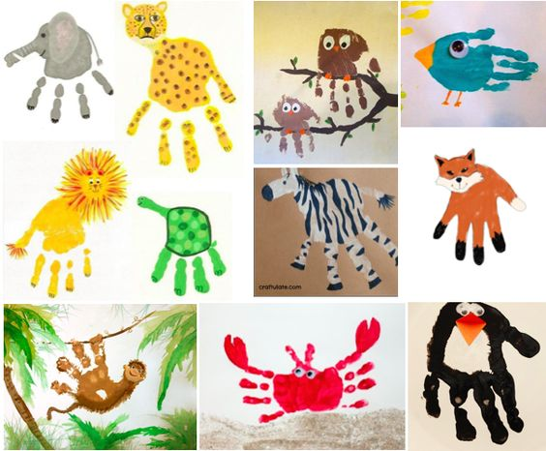  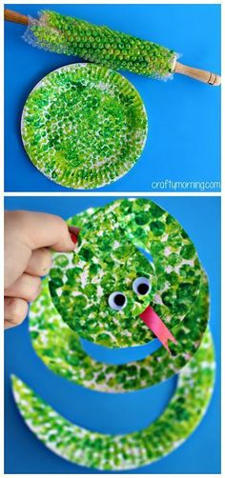  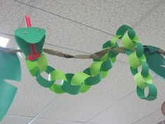  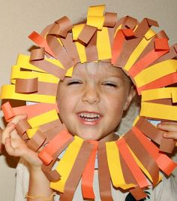  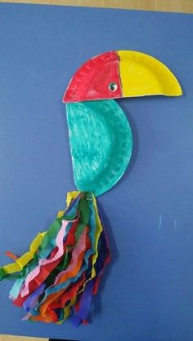  KS2 Ideas  A montage of different animals  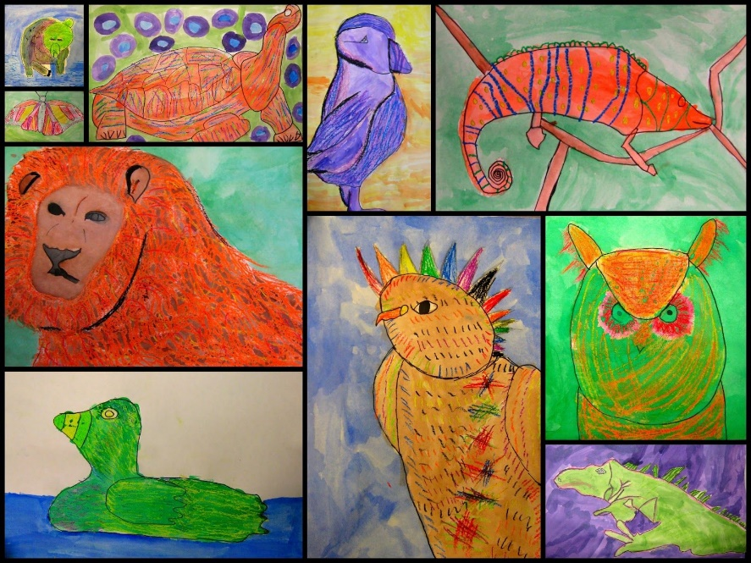  Simple but effective sculptures!  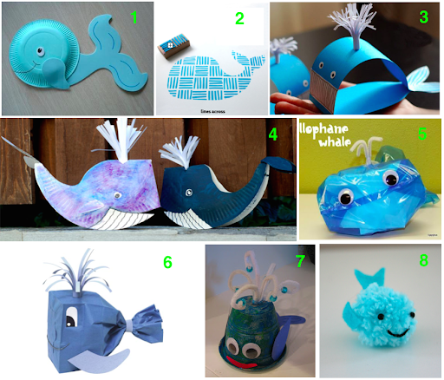  You could also create a wax resist image:  You will need:  - Paper  - A white candle or white wax crayon  - Decide on your image  - Draw the image using the candle or crayon  - Using water colour paint or watered-down poster paint lightly paint over the page, your image will resist the paint and will show up.  - To develop this technique further:  - Do a simple drawing – paint wash it – let it dry  - Add more detail – paint wash over that area – let it dry  - Add further detail and as above  - This enables you to add layers of colour and detail making your image more complex – have a go!

