This week, we are going to be learning about Time.
Today we will focus on the days of the week.

To refresh your brains, let’s practise the vocabulary of ‘after’ and ‘before’.
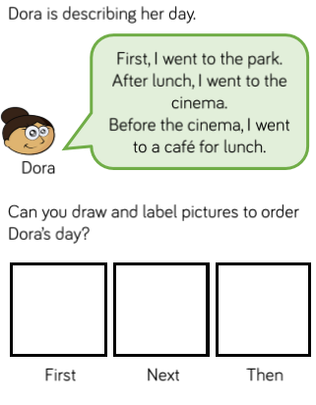

Days of the Week
You have 10 seconds to repeat the days of the week… GO!
Good, I knew you’d remember (hopefully!) – now see if you can fill in the missing words in these questions:
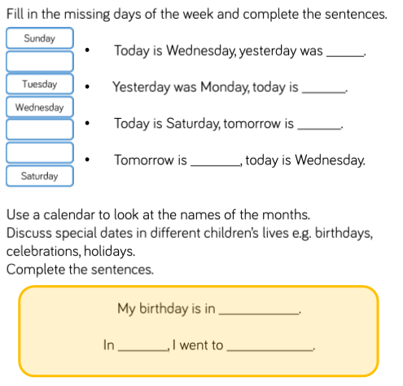

Problems to Solve!
*In the first question, it should read: The 5th*
